**Data Supplement**

**About**

DataMine is an inaugural data mining competition hosted by the UF Jacksonville College of Medicine’s Center for Data Solutions (CDS). Participants will mine literature and open-source data to help solve a pressing clinical issue. Participants will use modern data visualization techniques to create an infographic and slide deck presentation for judging by faculty from UNF and UF College of Medicine Jacksonville.

For all information, [Click here](https://github.com/doremon3210/Data-mine-competition-2021).

**Descriptive Statistics**

[Click here](../Results/descriptive_statistics_table.xlsx) for the descriptive statistics table

**Software**

We used Tableau to make graphs.

For the simple linear regression graphs, there are buttons on the right side to change the different variables.

**Diabetes Maps**

We made the maps that show the total of diabetes-related ED visits and diabetes-related deaths by counties.

To interactive with the maps [Click here](https://public.tableau.com/app/profile/huy.nguyen7870/viz/DiabetesMap_16375300872700/Dashboard2?publish=yes)

**Primary outcome: Diabetes related ED visits**

I. Univariate analyses

*Main analysis (Overall)*

We are 95% confidence that for every one unit decrease in the Median household income in county, the diabetes related ED visits increase by 0.0056.​

To interactive with the graph [Click here](https://public.tableau.com/app/profile/huy.nguyen7870/viz/UnivariateanalysesOverall/Dashboard1?publish=yes).

*Sub-analysis (White)*

To interactive with the graph [Click here](https://public.tableau.com/app/profile/huy.nguyen7870/viz/UnivariateanalysesWhite/Dashboard3?publish=yes).

*Sub-analysis (Black)*

To interactive with the graph [Click here](https://public.tableau.com/app/profile/huy.nguyen7870/viz/UnivariateanalysesBlack/Dashboard4?publish=yes).

II. Multivariable analyses

In the visualization of multivariable analyses, we found the coefficients and y-intercept each variable in Phase 2. We use these coefficients to visualize the multiple linear regression model. We odd the parameter each variable, and the parameter increase from -1 to 1 which variable increase or decrease by 0.1. If the slope of the variables is positive, the total number of Death Diabetes increases when the parameter increase. We visualized the main analysis and sub-analysis in Tableau. ALL visualization of graphs for total is on [Tableau](https://public.tableau.com/app/profile/shoto.fukuda/viz/DiabetesMultiplelinearregressionmodel/Dashboard2?publish=yes), and the visualization by each county is [here](https://public.tableau.com/app/profile/shoto.fukuda/viz/DiabetesMultipleLinearRegression/MultiplelinearregressionDiabetes). You can select the main analysis or sub-analysis on the top right corner of the dashboard.

*Main analysis (Overall)*

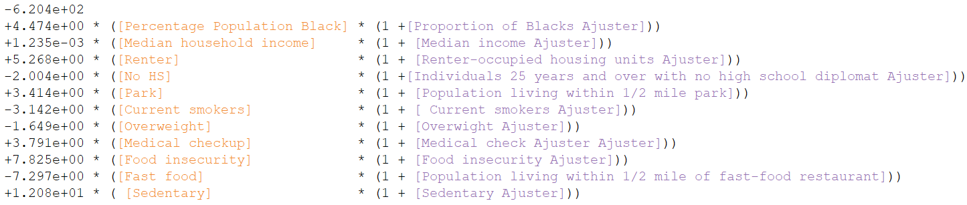

*Sub-analysis (White)*

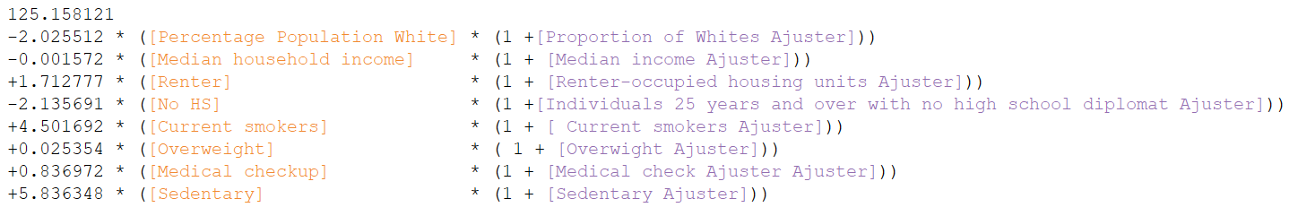

*Sub-analysis (Black)*

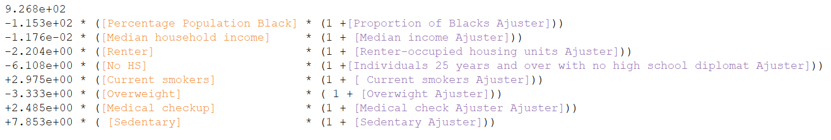

**Secondary outcome: Diabetes related deaths**

I. Univariate analyses

*Main analysis (Overall)*

To interactive with the graph [Click here](https://public.tableau.com/app/profile/huy.nguyen7870/viz/SecondaryoutcomeOverall/Dashboard1?publish=yes).

*Sub-analysis (White)*

To interactive with the graph [Click here](https://public.tableau.com/app/profile/huy.nguyen7870/viz/SecondaryoutcomeWhite/Dashboard3?publish=yes).

*Sub-analysis (Black)*

To interactive with the graph [Click here](https://public.tableau.com/app/profile/huy.nguyen7870/viz/SecondaryoutcomeBlack/Dashboard4?publish=yes).

II. Multivariable analyses

*Main analysis (Overall)*

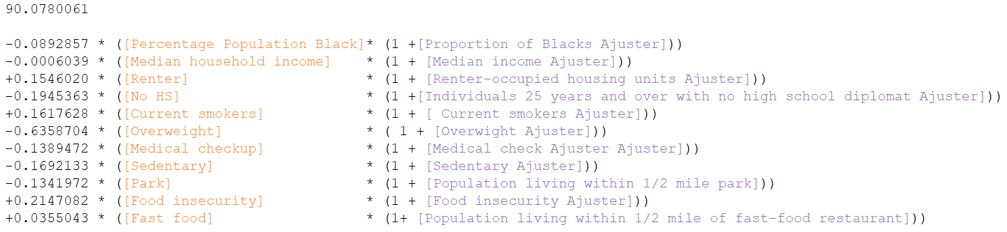 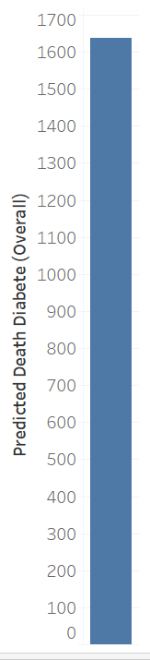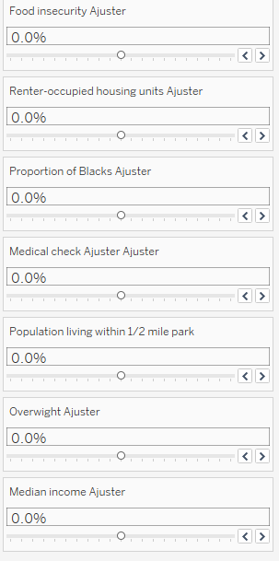

*This result will show the predicted the number of Diabetes related deaths.

*Sub-analysis (White)*

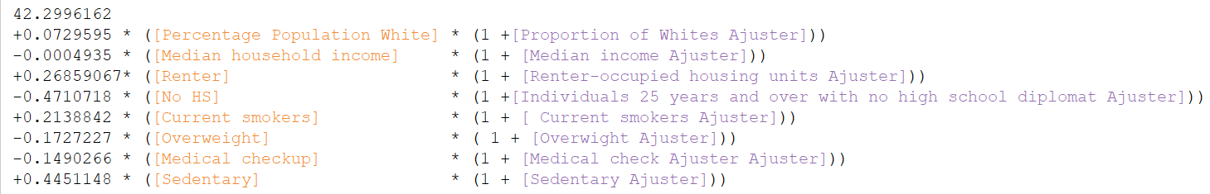

*Sub-analysis (Black)*

